Crowd Monitoring System Using Using YOLOv11 and YOLOv10 And Benchmark Analysis And YOLOv10 Comparison

S. Induja¹, K. Abirami², S.S. Rohith Hariharan³, K.C. Sriharipriya⁴
1,2,3,4- School of Electronics Engineering, Vellore Institute of Technology, Vellore.
Corresponding Author: sriharipriya.kc@vit.ac.in

ABSTRACT
With rising population density in public places, effective crowd monitoring system is necessary for safety. Traditional systems rely on manual monitoring, which is inefficient in the case of large-scale deployment. This project proposes an AI-driven systems which uses YOLOv11 and YOLOv10 for crowd detection. The models are compared based on inference time, frame processing time and people count to determine the optimal choice. An Arduino-controlled LED and buzzer are integrated to provide on-site immediate alerts, while Twilio-based SMS notifications are used to communicate to off site authorities. By combining deep learning with automated alert, this system offers a scalable and efficient crowd management system.

INTRODUCTION
With the rapid urbanization and a highly increasing population, public areas like shopping malls, religious sites, stadiums and transportation hubs, managing large crowd has become a great challenge. Preventing overcrowding, ensuring public safety and responding to emergency situations quickly is crucial. However, the existing crowd monitoring methods rely on human operators, who watch live video streams ands and decide and act based on what they feel at that particular instant. This approach is time consuming and exhausting and are liable to human errors. Moreover, in highly dense areas it becomes difficult to track and observe every part of the crowd effectively.
To solve this issue, the project implements an automated crowd monitoring system powered by Artificial Intelligence and Machine Learning. The project primarily uses the YOLO (You Only Look Once) deep learning model to analyze the video streams and predict the crowd density accurately. By comparing the YOLO—YOLOv11 and YOLOv10 projects targets to find the best balance between speed, accuracy and computational efficiency for practical use.
The key feature of this project is, the automated alert mechanism. As the crowd density reaches a critical point, an Arduino controlled LED and buzzer activate, to provide an instant warning at the location. Also, the system sends real-time SMS notification through Twilio to alert the offsite security teams or the authorities to take faster actions.
By combining the AI-based crowd detection with the real-time alert mechanisms, this model helps improve the public safety to a greater extent. It reduces risks, and makes crowd management more efficient. It provides a flexible and effective solution to handling large crowd in a smart, automated and efficient way.
LITERATURE SURVEY
Pedestrian detection and crowd monitoring have noticed significant advancements with the incorporation of deep learning models, in specific the YOLO (You Look Only Once) model. Recent researchers are focusing on improvising the inference speed, detection accuracy and the efficiency which helps in enhancing public safety.
In [1], the authors have introduced an improved YOLOv4 based model which has been designed to assess the number of people in a crowd including their movement and direction. They have applied strategies and convolution attention models to enhance the model’s accuracy and reducing the computational load. The mean Average Precision has been recorded as 92.1%, which shows significant improvements in real-time crowd detection. This study main features the effectiveness of optimized YOLO models in large-scale applications.
The study [2] focuses on evaluating the different models for crowd detection. A comparative analysis has been made on the key performance metrics such as accuracy, processing speed and inference time. By analyzing the various aspects of YOLO architecture, the study provides a conclusion into selecting the most efficient model for varying environments. Hence, the study contributes to improving real-time surveillance systems which helps the developers and research fellows choose the best version for various applications.
In this research [3], the authors have developed a smart crowd monitoring system that integrates IoT (Internet of Things) and deep learning. YOLO-GHOST is an optimized version for energy efficiency and real-time performance. The research involves collecting and processing of crowd data and integrating automated alerts in case of overcrowding. It specifically focuses on application in smart cities, where IoT-based surveillance could possibly enhance security at crowded areas like malls, hubs and public events.
The study [4] has explored the pedestrian detection using the latest YOLOv9 model. The aim of the study is to improve the processing speed and accuracy in detection for applications related to autonomous vehicle. The system is capable of detecting pedestrians accurately in varying environmental conditions. Additionally, the framework also allows the system to operate at a very low latency and nominal computational overhead. This study mainly contributes to development of safer urban mobility solutions which sets a base for future researches on automated vehicles and pedestrian monitoring.
The comprehensive review of YOLO models that include YOLOv1 to YOLO10 was conducted in [5]. This study focuses on the evolution of the YOLO architecture , and highlights the improvements in accuracy, efficiency and speed. The findings point out that the YOLO models offer great performance in the case of real time object detection applications which include crowd surveillance, autonomous navigation and security monitoring. The research provides worthwhile information which assists us to choose the best model for a particular application.
Additionally, many studies have focused on improving the real- time crowd counting using YOLO. In [6] an IoT-Integrated system with OpenCV and YOLO has been used for precise and accurate crowd density estimation. [7] compares YOLOv8 and Derectron2 which is to show the advancements in efficiency and accuracy. [9] introduces a multi view fusion approach for large scale applications, while [10] explores loss function optimization for enhanced crowd detection. [11], [12], [13], [14] and [15] are researches on Crowd counting and head detection. These demonstrate the real-world applications and highlight the effectiveness of these models
PROPOSED SYSTEM ARCHITECTURE
This proposed system follows a structured pipeline that allows real-time object detection and response. The system starts by processing the data sets which are the video streams, they are subjected to YOLO based object detection model. Every alternate frame is monitored and processed to identify the number of people and objects present in the scene. Every time the crowd goes past the predefined threshold value, the alert mechanism that includes the hardware and the messaging services is triggered. The Arduino board is triggered when ever necessary to activate the LED and Buzzer, which provides an on-site notification. In addition the Twilio API sends an alert message through SMS.to the registered number, which enables an offsite alert. To compare the system efficiency of YOLO v10 and YOLO v11, inference time, frame processing time and the people count are logged in an Excel file and are used for benchmarking. This approach makes sure quick response, automated monitoring and performance evaluation which on the whole makes it a comprehensive solution to the modern efficiency analysis.

Figure 1. Proposed system architecture

METHODOLOGY
The implementation of the system follows six steps which is as follows
Step 1: Video stream processing
- The system reads multiple video streams at the same time to simulate the real-time conditions
- OpenCV is used to extract individual frames at a fixed frame rate.
- The streams are re-sized to match the input size requirements and to organize the output streams.
Step 2: YOLO-based object detection
- YOLOv11 and YOLOv10 (Nano) models are used to analyze the frames.
- Object detection is executed which is followed by drawing boundary boxes around detected people and objects.
- Each detection is classified based on a confidence score to avoid false positives.
Step 3: Threshold checking for crowd
- A threshold value is set for the system to detect overcrowding conditions, the threshold value can be altered based on the environment.
- Alert system is triggered when the persons count exceeds the threshold.
Step 4: Arduino Uno based alert system
- A serial connection is established by the system to communicate with an Arduino Uno board
- As the crowd limit exceeds, the serial port is triggered which leads to the functioning of the Arduino ide code.
- During normalized crowd conditions, the deactivation signal is triggered and brings the system to normalized condition.
Step 5: Twilio SMS Alerts
- During over crowding conditions, alert signal is sent to the registered mobile number.
- It gives targeted responses.
Step 6: Performance Benchmarking
- The system records the FPS, frame processing time, YOLO inference time and the people count for YOLOv10 and YOLOv11 separately under the same conditions.
- Data is stored in Excel files, which enables us to use the data for graphical and other forms of representations.

EXPECTED OUTCOMES
Accurately detect crowd density
- Achieve higher accuracy than the previous YOLO versions
- Maintains reliable performance under low-light, varying crowd sizes and occlusion
Multiple video stream monitoring
- Processes multiple video streams simultaneously with minimal latency.
Trigger Immediate Alerts
- Powers up Arduino-controlled LED and Buzzer, when the crowd exceeds a predefined limit.
- Sends immediate SMS notifications through Twilio to the security personnel
Benchmark YOLOv11 vs YOLOv10
- Provide a quantitative comparison analysis of inference time, frame processing time and the people count (accuracy).
- Determine the most scalable and efficient model for implementation in real-world surveillance systems.
Enhanced public safety and crowd management
- Assisting security teams to avoid overcrowding occurrences.
- Improved response time during critical conditions like emergency evacuation.

HARDWARE AND SIMULATION SETUP
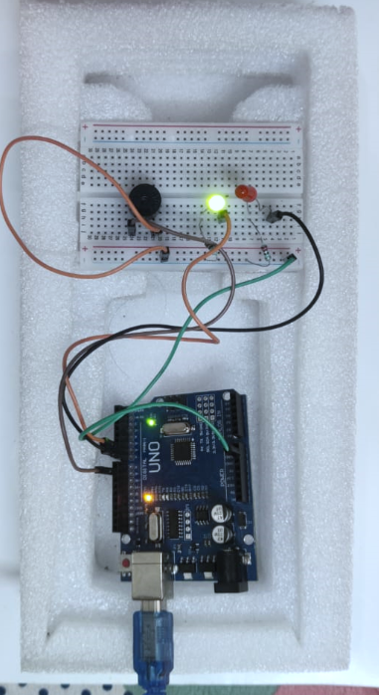
Fig 2. Hardware setup

RESULTS
Model | Video1 | Video2 | Video3
YOLOv11 | 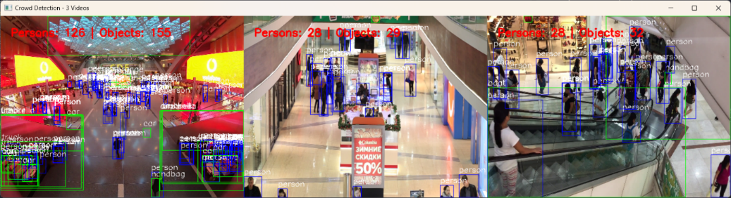 | 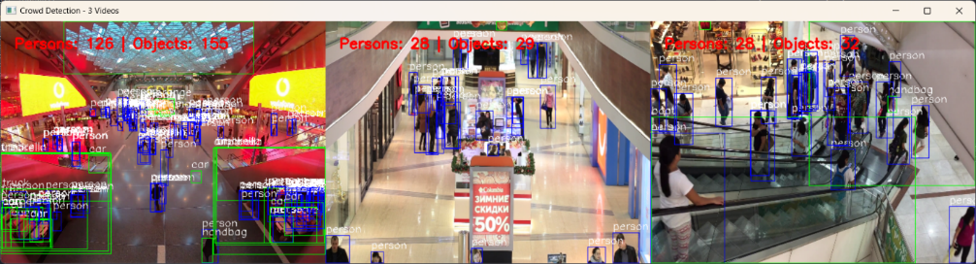 | 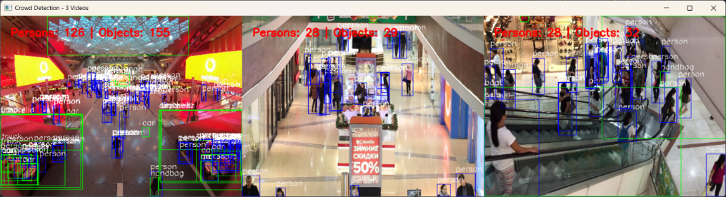
YOLOv10 | 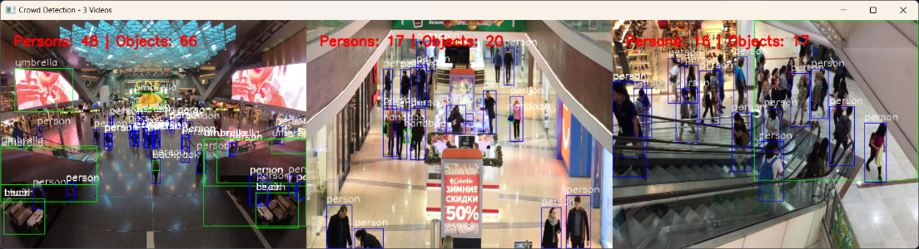 | 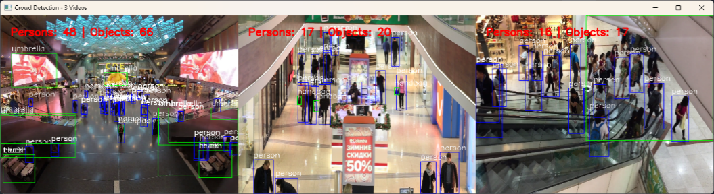 | 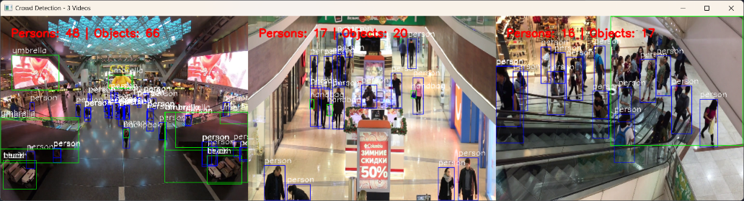

Table 1. Video streams post detection YOLOv11 and YOLOv10

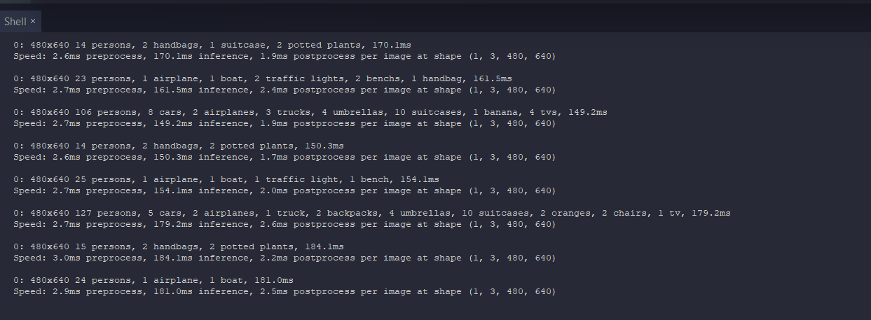

Figure 3. Output at the terminal

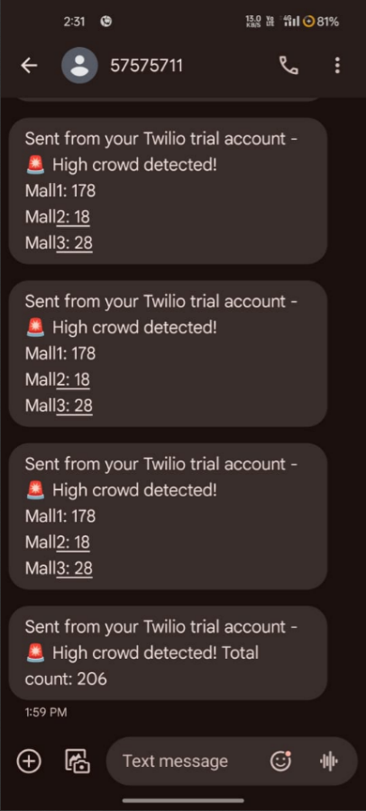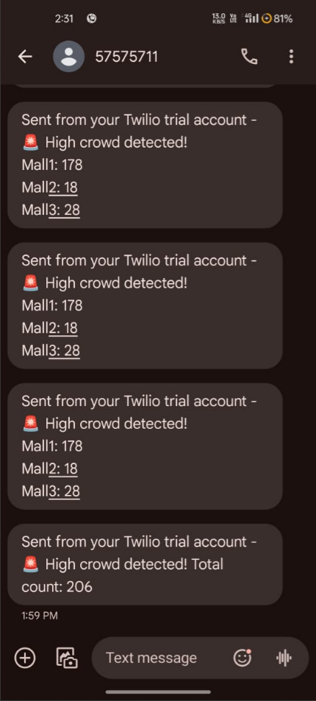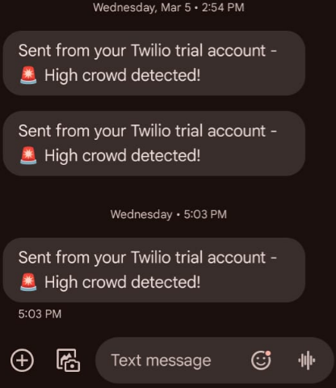

Figure 4 and 5 Message alerts using Twilio API

Normal – Powered ON | Overcrowd – Powered ON
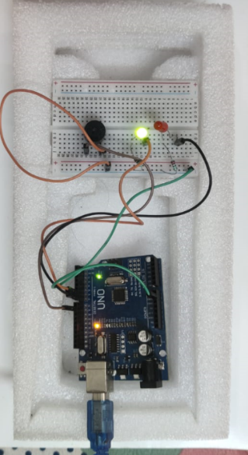 | 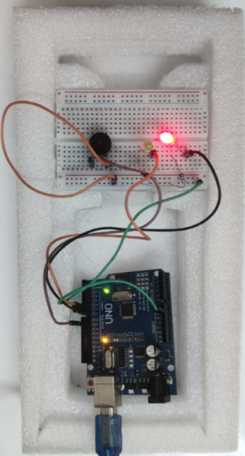

Table 2. Hardware Output during normal and overcrowded

People Count-Accuracy | Inference Time (sec) | Frame Processing time (sec)
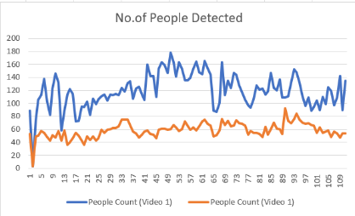 | 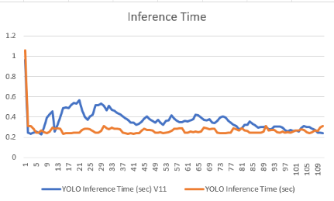 | 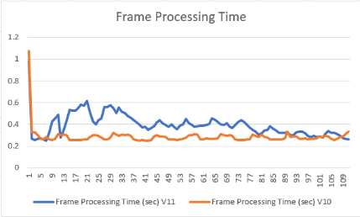

Table 3. Benchmark Analysis for people count, inference time and frame processing time

DISCUSSION AND COMPARISON
The results indicate that in terms of accuracy YOLOv11 performs better by detecting the right number of people when compared to YOLOv10. The people count graph [Table 3] shows that YOLOv11 detects more individuals in nearly all the frames, which shows a key improvement in object recognition and detection. This makes YOLOv11 more dependable for crowd monitoring and security surveillance related applications, where precise detection is critical. But the improvement comes at a cost, as the detections get better the time taken to process is also higher which make it computationally more demanding.
In terms of speed, YOLOv10 is the better choice. The frame processing time and the inference time are lower, which indicates that YOLOv10 can process frames faster and it is clearly evident in the Table 3. Making suitable for real-time applications that require quick and instant response. The trade-off here is speed vs accuracy, the model selection depends on the application’s requirements.

Factor | YOLOv11 | YOLOv10 | Best Choice
People Count (Accuracy) | Higher | Lower | YOLOv11
Inference Time | Higher | Lower | YOLOv10
Frame Processing Time | Higher | Lower | YOLOv10
Overall Detection Performance | Better | Weaker | YOLOv11
Table 2. Analysis table

On considering both efficiency and accuracy, even at the cost of time, YOLOv11 is optimal for applications where detection precision is the priority. On the other hand, YOLOv10 is a better option for applications which require faster processing speed. The final decision depends on whether the detection accuracy or speed is more important in the proposed application. Since this project focuses more on crowd management which requires accurate results of the people count, YOLOv11 is preferred. However, the inference time and frame processing time of YOLOv11 can be optimized through hardware acceleration or model pruning, while maintaining high accuracy.

CONCLUSION
This study presents a crowd monitoring system that combines Machine Larning (YOLOv11) for object detection and Arduino for alert mechanisms and Twilio-based remote notifications. The model processes multiple video streams, keeps track on the crowd density and triggers alert when the threshold is exceeded.
The analytical results shows that, YOLOv11 outperforms YOLOv10 in detection accuracy, which makes it more suitable for accurate and precise crowd estimations. On the other hand YOLov10 achieves faster frame processing time and inference time, but it underestimates crowd density, which might compromise safety. Despite the slightly higher computational demand of YOLOv11, it remains withing the operational limits. Moreover, hardware optimizations can also improve performance.
The system developed efficiently integrates deep learning-based detection, real-time alerting, which makes it a great solution to crowd management, emergency response and public safety. Future work will focus on optimizing the computational efficiency, enhancing deployment scalability and integrating multi-camera fusion.
.
REFERENCES
[1] M. H. K. Khel, K.A. Kadir, S. Khan, M. N. M. M. Noor, H.Nasir, N. Waqas, and A.Khan, “Realtime Crowd Monitoring-Estimating Count, Speed and Direction of People Using Hybridized YOLOv4,” IEEE Access, vol,. 11, pp.56368-56379, 2023.
[2] M. S. Gündüz and G. Işık, “A new YOLO-based method for real-time crowd detection from video and performance analysis of YOLO models,” Journal of Real-Time Inage Processing, vol. 20, pp. 1-15, 2023. Doi: https://doi.org/10.1007/s11554-023-01276-w
[3] D. R. Arun, C. C. Columbus, A. Bhuvanesh, A. S. Sumithra, “Smart Crowd Monitoring System Using IoT-Based YOLO-GHOST,” Rev. Roum. Sci. Techn.- Électrotechn. Et Énerg., vol. 69, no. 3, pp. 341-346, 2024. doi: https://doi.org/10.59277/RRST-EE.2024.69.3.15
[4] H. Kumar, P. Mamoria, and D.K. Dewagan, “Optimized Pedestrian Detection Leveraging YOLOv9: A Thorough Deep Learning Framework for Autonomous Vehicle System,” in Proceedings of the 2024 IEEE International Conference on Intelligent Signal Processing and Effective Communication Technologies (INSPECT), 2024. doi:10.1109/INSPECT63485.2024.10896195.
[5] C.-Y. Wang and H.-Y. M. Liao, “YOLOv1 to YOLOv10: The Fastest and Most Accurate Real-Time Object Detection Systems,” 2024.
[6] S. K. Jayasingh, K. J. Patra, P. Naik, M. R. Kabat, and S.Swain, “Integrated Crowd Counting System Utilizing IoT Sensors, OpenCV and YOLO Models for Accurate People Density Estimation in Real-Time Environments,” in Proceedings of the 2024 1st International Conference on Cognitive, Green and Ubiquitous Computing (IC-CGU), 2024. doi: 10.1109/IC-CGU58078.2024.10530804

[7] M. Wadhwa, G. Raj, T. Choudhury, and J. C. Patni, “Comparison of YOLOv8 and Detectron2 on Crowd Counting Techniques,” in Proceedings of the 2023 7th International Synoposium on Innovative Approaches in Smart Technologies (ISAS), 2023. doi: 10.1109/ISAS60782.2023.1039146
[8] A. Ranjan, N. Pathare, S. Dhavale, and S. kUmar,” Performance Analysis of YOLO Algorithms for Real Time Crowd Counting,” int Proceedings of the 2022 2nd Asian Conference on Innovation in Technology (ASIANCOn), 2022.
[9] Q. Zhang and A. B. Chan, “Wide-Area Crowd Counting via Ground- Plane Density Maps and Multi-View Fusion CNNs,” in Proc, IEEE/CVF Conf. Comput. Vis. Pattern Recognit. (CPVR), Jun. 2019, pp. 8289-8298.
[10] Dai F, Liu Z, Chan AB, “A Generalized Loss Function for Crowd Counting and Localization,“ in Proceedings of the IEEE/CVF Conference on Computer Vision and Pattern Recogonition (CPVR), Nashville, TN, USA, 2021, pp. 1974-1983. doi: 10.1109/CVPR46437.2021.00201.
[11] A. K. Suhane, A. Vani, H. Parihar, U. Raghuwanshi, A. Nimbark, and L.Saxena, “Human Detection and Crowd Counting Using YOLO,” Tech Fest IIT Roorkee, Apr 2023.
[12] M. Ptak, P. Meikina, P Janik, and L. Smaga, “Counting People and Bicycles in Real-Time Using YOLO in Jetson Nano,” Energies, vol.15, no. 23, p. 8816, Dec.2022. doi: 10.3390/en15238816.
[13] S. Sharma, A. Agarwal, and P. Kumar,”Analytical Study of YOLO and Its Various Versions in Crowd Counting,” in Lecture Notes in Networks and Systems, Springer, 2021, pp. 845-856. doi: 10.1007/978-981-16-7610-9_71.
[14] M. Hassan, F. Hussain, S. D. Khan, and M. Ullah,”Crowd Counting Using Deep Learning Based Head Detection,” Electronic Imaging, vol.35, no. 9, pp. 293-1-293-6, Ja. 2023.
[15] P. Ren, W. Fang, and S. Djahel, "A Novel YOLO-Based Real-Time People Counting Approach," in Proceedings of the Third IEEE Annual International Smart Cities Conference (ISC2), Wuxi, China, Sep. 2017.

